**LEBANESE AMERICAN UNIVERSITY**

**USAID – HIGHER EDUCATION SCHOLARSHIP PROGRAM**

**HES - Volunteering Program Verification Form**

This form is to be used to document volunteering hours. If a student volunteers for multiple organizations, a separate form must be used for each organization. **This form must be turned in by the 28th of each month, the latest.**

I certify that the scholar Abed Al Karim Sharouf completed a total of 1 hours of service at Life Sculptor.

The hours were completed hours as per the below:

Hours # 1 (date) _30/09 – 5/10_ (initials of supervisor) __A.K.___

Hours # 0 (date) _7/10 – 11/10_ (initials of supervisor) __A.K.___

Hours # 0 date) _14/10 – 18/10 (initials of supervisor) __A.K.___

Hours # 0 date) _21/10 -25/10 (initials of supervisor) __A.K.___

Brief description of the activities the scholar performed or participated in:

Conducted an online research the future of auditing with AI and machine learning  
- Searched for cardible sources.  
- Analyzed information.  
- Prepared a documented explanation of the areas mentioned previously.  
- Cited resources.   
- Submitted my research to be reviewed and used for a presentation material by the hub team.

Written feedback about the scholar’s performance:

Abdelkarim's comprehensive research on the future of auditing with AI and machine learning showcases his ability to analyze complex information and present it in a clear, documented format for future reference and presentations.

Please rate the overall performance of the scholar at your organization:

|  |  |  |  |
| --- | --- | --- | --- |
|  | Mastery (5) | Proficient (3) | Emerging (1) |
| **Problem solver** | X |  |  |
| **Engaged & Committed** | X |  |  |
| **Open-minded & multicultural** | X |  |  |

Signature

& stamp

__________________________

_

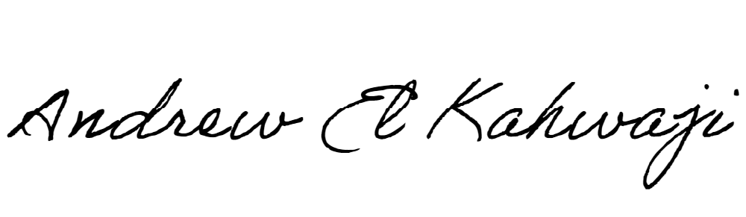

Printed Name _Andrew El Kahwaji_

Date __26/10/2024___

Email __andrew.lifesculptor.coo@gmail.com __

Phone __+961 71 914 378__

**LEBANESE AMERICAN UNIVERSITY**

**USAID – HIGHER EDUCATION SCHOLARSHIP PROGRAM**

